CR-BACKUP USER MANUAL

V. 1.60 – Nov. 1, 2004

Disclaimer

Alberta Computer Services makes this User Manual available on an "as is" basis.
Under no circumstances does ALBERTA COMPUTER SERVICES warrant or certify the information to be free of errors or deficiencies of any kind. ALBERTA COMPUTER SERVICES specifically disclaims all warranties, express or implied, including but not limited to the warranties of merchantability and fitness for a particular purpose.

This information is subject to change by ALBERTA COMPUTER SERVICES. Anyone relying on this information should satisfy himself/herself as to the most current version. The user agrees to accept all risks and consequences flowing from or related to the use, retention, distribution, alteration, or deletion of this information. ALBERTA COMPUTER SERVICES will in no instance be liable for any loss of profit or other damage, including but not limited to special, incidental, consequential, or other damages, even if apprised of the likelihood of such damages.

The software described in this manual was developed by, and is the intellectual property of, ALBERTA COMPUTER SERVICES. © 2004

Table of Contents

1. Overview 1
1.1 How does it work 1
1.2 Encryption 2
1.3 FTP 2
1.4 Web site 2
2. Installation 2
2.1 Default path 2
2.2 Uninstall 2
2.3 Automatic launch 3
2.4 Icon in tool tray 3
3. Configuration 3
3.1 Auto recommend 3
3.2 Config tab 3
3.2.1 Passwords 4
3.2.2 Password reminder 4
3.2.3 Backup only between 4
3.2.4 Auto update 4
3.2.5 Full backup only monthly 4
3.2.6 Email address for alerts 4
3.2.7 This IP address 4
3.2.8 CPU priority 5
3.2.9 Clear Archive Bit 5
3.3 Select Files tab 5
3.3.1 Browse 5
3.3.2 Show backup set size 5
3.3.3 Adding/removing path 5
3.3.4 Excludes 6
3.3.5 Do not back up files...... 6
3.4 How are the IP addresses of the Hosts found 6
4. Backing up 6
4.1 When 6
4.2 Incremental vs. full 7
4.3 Progress bar 7
4.4 If main server does not respond (or file size does not match) 7
4.5 Stats 7
5. Restoring 7
5.1 Logon to web site (link from Rconfig, tooltray) 7
5.2 File space used 8
5.3 Search 8
5.4 Calendar 8
5.5 Restore from anywhere 9
6. Archiving 9
6.1 Archive 9
6.2 Restore 10
7. Remote take-over 10
8. Security 11
9. APPENDIX A 12

Congratulations! You are about to enjoy the protection of the most advanced and easiest to use Remote Backup system on the market.

Before you begin, a couple of points to keep in mind:

- Keep the size of your backups as small as possible (the compressed backup must not exceed 2 Gigabytes). The smaller your backups are, the longer it will take before you exceed your storage allotment, the faster the backups will complete and the higher the chances they will complete properly every time.
- Look at the default file types that will not be included in your backups (e.g. Executables, PDF files etc.) and modify this list as required.
- You will need sufficient free space on your drive for the temporary files created by this program. As a rule of thumb, you should have at least half as much as the amount of data you'll be backing up each time. The default location for these temporary files is on your C drive but you can change this to another drive. If you use a drive on another computer or on a file server, the backup process will take a lot longer.
- You can back up any file or folder that you can see from your Windows Explorer screen, such as drives on another computer or server that you have access to.
- This program will back up files that are in use by other programs, but not if they were opened in “exclusive” mode (which, for instance, many database programs would do).
- You can install this program on as many machines as you want but if they all use the same account name, each backup will overwrite any other backups from that day.

Overview

How does it work
CR-Backup is a program that runs on your PC in the background and periodically creates a backup of the folders and/or files you have chosen. It then copies this backup to our secure server where you can access it anytime, from anywhere on the Internet. This process normally occurs once a day, with an “incremental” backup done daily and a “full” backup done once a week.

The backup file is first compressed, then encrypted (using military grade encryption) and then converted to an executable program so that it can be accessed from any PC without requiring any special software on that PC. As soon as CR-Backup is ready to begin another backup, it will display a status screen showing you what folder it's backing up or how much of the backup file has been uploaded to our servers. On this screen, you can click on Cancel in case you are working on something and don't want to be slowed down or interrupted by the backup process or any of its messages.
Your backups are stored on our File Servers (Firewall, virus and power protected) for up to one year or more and can be easily accessed through a calendar so that you can pick the month or day that you want to retrieve your files from.

In addition, you can also archive any of your files. This is different than backing up your files in that it removes the files from your PC. This allows you to clean up the clutter on your PC and store some of the files that you don’t use very often in a remote but secure and easy to access place.

Encryption
Your backed-up files are encrypted before the data leaves your PC. This prevents anyone, including our staff, from being able to see any of your files. The data is encrypted using the latest 256 bit AES (Advanced Encryption Standard) Military grade encryption and uses a password that you supply as a seed for the encryption process.

FTP
After your backup files are created, they are copied to our File Server using the FTP protocol. This means that your PC, network and Firewall must allow outgoing FTP transfers. There are no other changes you need to make to any of your Firewalls or Proxy servers.
You can also use a standard FTP client (e.g. WS-FTP) to up and download files to your account, but these files will then not be automatically compressed or encrypted.

Web site
From our web site at: www.calgarybackup.com, you can access your account by clicking on “Login to your account” on the left hand side. You can easily get to our web site by clicking on the “Web site” button on the main Config screen. If you need to install CR-Backup again, you can do that directly from the download page.

After you log in to your account, you will see a link under Tools on the left side called: “Remote Control”. This link points to the most recent IP address that was assigned to the PC that performed the last backup to our File Server. If you have the VNC remote control program (free from www.uk.research.att.com/vnc/) on that PC, you can click this link and go directly to the logon screen of VNC on your PC. Go to our Download page (www.calgarybackup.com/downloads.html) if you want to install this remote control functionality on your PC.

Installation

Installation of CR-Backup is quick and simple. On most systems, the entire process, from downloading to configuration, can be completed in less than a few minutes.

Default path
The CR-Backup installation will by default create a folder called CR-Backup in your Program Files folder. You can choose to install it in any other drive or path.

Uninstall
CR-Backup is installed using a standard Microsoft installer program so that you can go to the Control Panel – Add/Remove Programs and uninstall CR-Backup. This will not delete all the event logs and configuration files in the CR-Backup program folder so you may want to manually delete the entire folder after the un-install process is finished.

Automatic launch
When CR-Backup is first run, it will create a Shortcut to the CR-Backup program, and places it in your special Startup folder. This will ensure that CR-Backup is started every time your PC is started or re-booted. If you have multiple user accounts on your PC, the shortcut will be placed in the “All Users” folder so that CR-Backup is automatically loaded for any of your users. The configuration process will then start automatically (with certain personal firewalls, the configuration program may not be able to connect to our file server immediately. If this happens you may need to close the configuration program and re-start it from the CR-Backup icon in the system tray).

When the configuration process is complete, CR-Backup will be automatically started so you will see a splash window very shortly thereafter indicating that your first backup is about to begin.

Icon in tool tray
Whenever CR-Backup is running and protecting your files, an icon that looks like a yellow or orange square safe will appear in your Tool Tray (where your clock is normally displayed). By holding the cursor over this icon, you can see the version of the software you are currently at.

Configuration

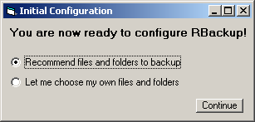
Auto recommend
The first time you run CR-Backup, it will run the Config program first. The first time this is done, it will ask you if you want to choose your own files to backup or if you want the Config program to recommend some choices for you. If you let the program recommend folders, you can still add or delete any files and folders after that.

Config tab
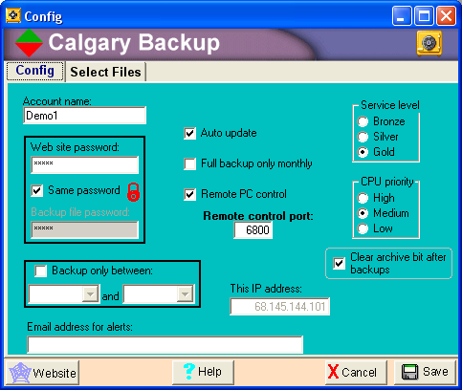
Clicking on the Config tab will allow you to set your Account name, password(s) and type of service. These settings are automatically verified when you click on Save (by attempting to connect to our main File Server using the Account and Password you supplied). If a proper connection can not be made, you will get an appropriate error message and allow you to change settings and try it again.

Note: the first time this program is run it will have a default account called Demo1 (password: Demo1) that you can use to try out the service. Once you get your own account set up, you will need to replace the Demo1 account with your own user name and password.

Passwords
In the Web site password field, you set the password that was created for you when we set up your account. By default, the same password that allows you to log on to our File Server is used to encrypt your backups before they are sent from your PC. However, you can also choose to set a different password for the encryption process for additional security (this second password will never be transmitted across the Internet). When you access your backups for retrieval, you will then need one password to log in to your account on our File Server, and a different password when you retrieve any of your backups.

You can change your account password on our File Server after you have logged in but you will then have to remember to also set this same password on your PC (by right-clicking on the CR-Backup Icon in the Tool Tray and selecting “CR-Backup Config”).

Password reminder
After you set or change your password, you will be asked if you want to set a password reminder. You can enter any word or phrase (e.g. mother’s maiden name, favorite color) that would help you remember what password you used. You can access this reminder by right-clicking on the CR-Backup icon in the Tool Tray and clicking on “Password?”.

Backup only between
If you do not wish to be interrupted by CR-Backup while you are working, and plan to leave your PC on over night, you can click this option and select a time range when backups will occur. When another backup (full or incremental) is due, CR-Backup will then check to see if the local time is in this range and begin the backup. If it is not, it will continue to check every 5 minutes.

Auto update
With this option checked, CR-Backup will check for any new versions of any of the programs (Rconfig, CR-Backup, Update etc.) and will automatically download them. If CR-Backup itself is updated, it will shut down, rename the new version to CR-Backup.exe and restarts it. Normally this process will take about 5 seconds. Note: if you have a personal Firewall on your PC (e.g. ZoneAlarm, Kerio) you will likely get a pop up alert indicating the Rbackup application has changed so you will have to re-allow this program to access the Internet on a permanent basis.

Full backup only monthly
To minimize the amount of storage you use up on our servers, especially if your full backups are very large, you can choose to change the default weekly full backups to having them done only once per month.

Email address for alerts
If there are any alerts (backups not working properly, File Server down for maintenance etc.), they will be sent to this address.

This IP address
Rconfig automatically determines your public IP address (not the local IP address of your PC in case you are behind a Firewall) and uses this in the link that is shown on your Calendar page on the File Server. This allows you to always connect to your PC even if your ISP assigns different IP addresses from time to time (if you have a Dynamic instead of Static IP address).

CPU priority
You may want to change how much time is allocated by your operating system to the CR-Backup program. This can be useful if backups occur while you are working in another application and find that the backup process is slowing down your other program. You can also increase the CR-Backup priority if you want to have the backup process completed as quickly as possible.

Clear Archive Bit

Normally, this option should remain checked but to prevent a conflict with other backup programs running on the same PC, you can choose to have CR-Backup not clear or reset the archive bit on each file after its backup is done. This way, you can still run another backup program that can back up changed files (i.e. an incremental backup).

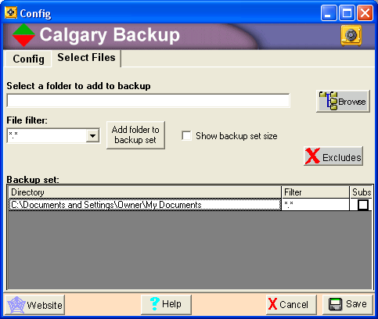
Select Files tab

Browse
Navigate the directory tree to select a folder (or specific file) to back up. Then set the File Filter (defaults to *.*) to select which files in that folder you want backed up. For example, you may want to select *.doc to have all your Microsoft Word files backed up. This field is not case sensitive. When you click on the “Add folder to backup set” button, the folder and File Filter or file you have selected will be added to the backup set list. CR-Backup will not automatically include all folders inside the folder you have selected (all subs) unless you click on the square box in the Subs column. If this is selected, the same File Filter will be used for any folders within your selected folder (if you selected the root of your drive, e.g. C:\ you will see a message warning you that this may take a very long time to back up as all folders within your C drive will be backed up as well).

Show backup set size
Clicking on this box will allow you to see the total size of all files that will be backed up. This number takes in to account the size of all the file types listed in the excludes list that will not be included in your backups. Important: CR-Backup needs at least this much free space on your hard drive in order to be able to compress and encrypt your data before it can send it to our File Server.

Adding/removing path
Right-click on any file or folder in the backup set grid, or select it and press Delete, to allow you to remove it from your future backups.

Excludes
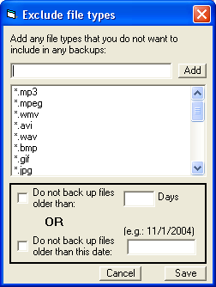
The Excludes button brings up a list of the file types that will not be backed up. This allows you to make sure that the important files are backed up but that the size of your backup remains reasonable. Use the Del key to remove file types from that list or type in a new file type and click Add. The following files types are excluded by default:

*.mp3  *.mpeg  *.wmv  *.avi  *.wav  *.bmp  *.gif  *.jpg  *.tif  *.exe  *.com | *.zip  *.dll  *.cab  *.*-  *.theme  *.tmp  *.lnk  Thumbs.db  *.ocx  *.bkf  *.pdf

Any changes you make to the excludes list will automatically cause the “Total size” field to be updated to reflect any new file types that will now, or will not be, included in the backups.

Do not back up files......
If you already have a copy of some of your older files stored somewhere else (or in a previous backup) you can choose to not back up these files every time. You can choose to exclude any files that are older than x days or older than a specific date (so that your backups will be smaller and faster).

How are the IP addresses of the Hosts found
Our Files Servers can not be accessed by Domain name as an extra security precaution. CR-Backup needs to use the actual IP addresses of the Primary and Alternate File Servers. If the web page where these IP addresses are stored can not be accessed (e.g. if HTTP traffic is blocked because of a password prompt) then the previous IP addresses (which were automatically saved in the CR-Backup.cfg file) will be used instead. The IP addresses are checked every 5 minutes.

Backing up

When
By default, CR-Backup will perform an Incremental backup every 24 hours and a Full backup every 7 days. You can also right-click at any time on the CR-Backup icon in the Tool Tray and select “Full backup” or “Incremental backup”. You can cancel a backup any time after it's started by clicking on the Cancel button on the main status screen.

Incremental vs. full
There are two types of backups that CR-Backup can perform: Incremental and Full. An incremental backup will find all files that have either been modified or created since the last full backup and make a backup file of just those files. A full backup simply copies all files and folders that you have specified, whether any of them have been recently modified or not.

Progress bar
During any file up or downloads, a progress bar will be displayed showing how much of the file being copied has already been transfered.

If main server does not respond (or file size does not match)
If for some reason the main File Server does not respond, or the backup file on the File Server is not exactly the number of bytes it is supposed to be, CR-Backup will re-try every 5 minutes, up to 10 times. If still not successful, it will try our alternate File Server (which is at a different site, using a different Internet Service Provider). This will ensure that your backups will always work. The alternate File Server will copy your backups to the main server (where you can access them from the Calendar page) as soon as it's accessible again.

Stats
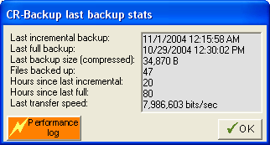
At the end of each backup, you will see a message indicating the number of files that were backed up. You can also right click on the CR-Backup icon in the Tool Tray and click on Stats to get any of the following information:

- Time/date of last incremental backup
- Time/date of last full backup
- The size of the last backup file
- The number of files in the last backup file
- Hours since the last incremental backup was done
- Hours since the last full backup was last done
- Transfer rate of last backup (in bits/sec)

The “Performance log” button will show you the contents of the performance.dat file to give you an idea of the speed of your past uploads.

Restoring

Logon to web site (link from Rconfig, tooltray)
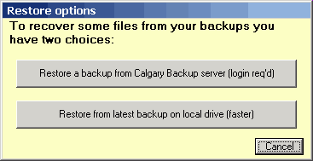
An easy way to get to our main web site is to click on the “Go To Website” button on the main Config screen. You can also right click on the CR-Backup icon in the tooltray and click on “Restore a backup”. This will bring up a window giving you an option to restore from our backup server or to restore from your own hard drive (after every backup, your backed up data is saved in a temporary folder on your hard drive and remains there until overwritten by the next backup).

The first option will launch a copy of Internet Explorer and goes directly to the web site logon screen. After you have logged in, you will then see a screen similar to the following page:
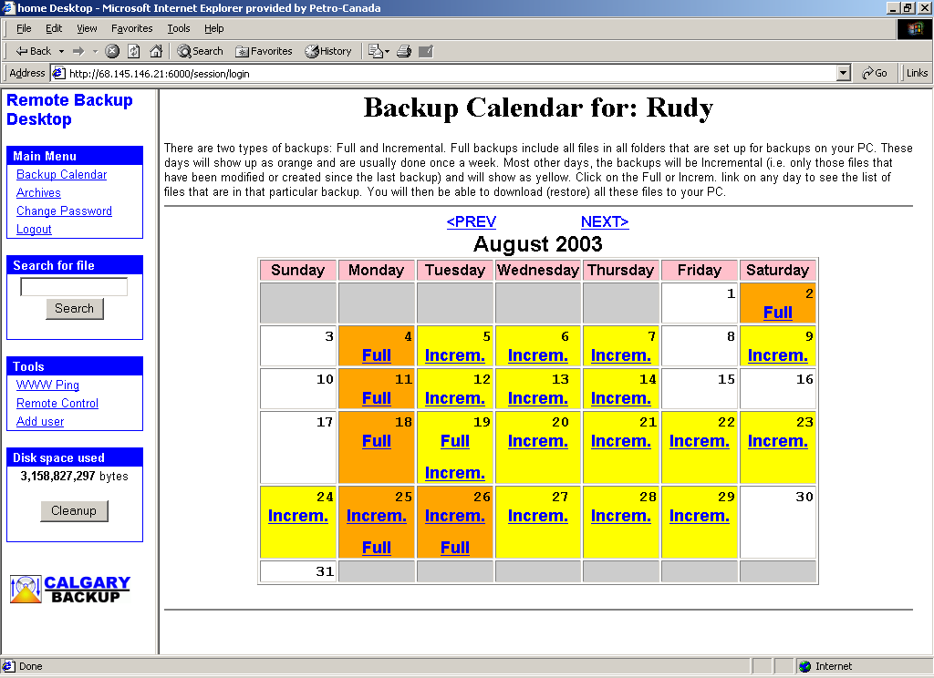
Note: The File Server is configured so that if you make multiple attempts to login with the wrong password, it will time out for 5 minutes before you can try again. This will prevent someone from using a “dictionary” attack to log in to your account.

File space used
The bottom table on the left side shows the amount of disk space all your backup and archive files are using on our File Server (in Bytes).

Search
You can search for any file name or part of a file name by using the Search box on the left side of the screen. This will then bring up a list of all the backup files that contain a copy of that file. Click on the backup file that you want to restore to your PC.

Calendar
After you have logged in you can locate all your backups through a simple calendar view (see above). Click on Prev or Next to go back or forward a month at a time. By clicking on the word Full or Increm. a page will be displayed that shows all the files that are in that particular backup, including the date the files were originally created on your PC and their original path/location. By clicking on the Download button on that page, you will be able to restore all these files to the PC that you are on.

Restore from anywhere
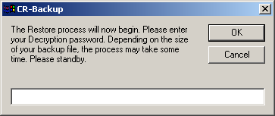
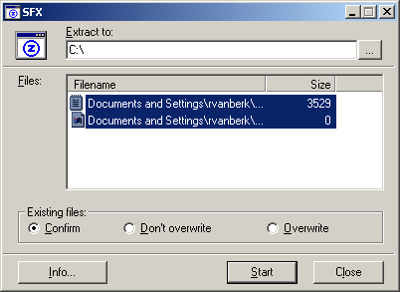
You do not need any special software to be able to retrieve your backups. Simply by clicking on any of your Full or Incremental backups from any Web Browser on any Windows PC, you will be able to retrieve your backup files. On the page that shows all the files that are in the Backup that you have selected, you will see a Download button. By clicking on that, your browser will ask you if you want to run the program or save it on disk. By selecting the Run option, you will see this password screen. If you have entered the correct password, you will then see the following screen, where you can specify where you want to restore your Backup files to (and which files you want to restore). It is recommended that you choose a temporary path (such as c:\temp) to restore your files. That will allow you to look at all the files that were backed up and decide which ones you want to keep and move to the folder(s) you want (or copy over any existing files).

Note: the PC you are restoring the files on to must allow the execution of .VBS (Visual Basic Scripting). This feature may have been disabled by your system administrator as a safety precaution against possible viruses. Also, some older PCs (e.g. Win95) may not have the Windows Scripting Host feature installed necessary to run .VBS files. You can download this from the Microsoft web site.

Archiving

Archive
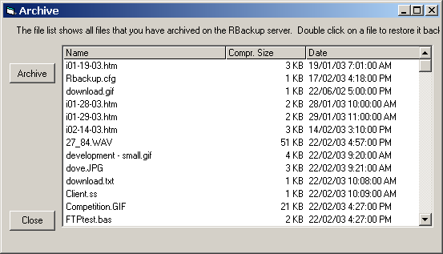
In addition to the normal backups, you can also archive any of your files. This is different than backing up your files in that the files are removed from your PC. This allows you to clean up the clutter on your PC and store some of the files that you don’t use very often in a remote but secure and easy to access place. The files are first compressed, then encrypted, then copied to our File Server and then deleted from your PC.

Restore
To restore any of the files you have archived, just double-click on the file and then choose a folder and file name to save it back on your PC. It will then be de-crypted and deleted from our File Server.

Remote take-over

By installing the Freeware VNC (Virtual Network Computing) tool from AT&T (www.uk.research.att.com/vnc/) on your PC you will be able to remotely access and manage it from anywhere on the Internet. Using any standard Browser, you can type in the IP address of your PC and get prompted to log in. You will then see your PC’s desktop in your browser window. All your mouse movements and keystrokes will then be sent directly to your PC as if you were sitting right in front of it.

The problem is that, because many Cable and DSL Internet users get assigned Dynamic IP addresses, you can never be sure of what your PC’s IP address is when you are away from your PC. However, every time CR-Backup runs, you have to option to have it determine your current IP address and upload that to our File Server. We then automatically create a hyperlink and display that on your Calendar page on our Server. Your browser will then take you directly to your VNC login when you click on this hyperlink.

Security

The protection of your files is extremely important to us. In fact, our whole business depends on it! We have taken multiple safety precautions to prevent anyone from accessing your account or your data files. These precautions include:

- The File Servers are configured so that if you make multiple attempts to login with the wrong password, it will time out for 5 minutes before you can try again. This will prevent someone from using a “dictionary” attack to attempt to log in to your account.
Note: we strongly recommend you use the following guidelines when creating your own password:
- Do not use any word that can be found in the Dictionary unless you combine it with another unrelated word (e.g. bookflower)
- Use a combination of upper and lower case and numbers (e.g. Now2Work)
- An even better method is to use an acronym for a phrase you can easily remember and which includes numbers (e.g. “Two is company, three is a crowd” becomes: 2ic3iac)
- We do not use Microsoft IIS or Apache, which have many known vulnerabilities and are popular targets of attack.
- We have hardened the Operating System of our Servers (i.e. removed all unnecessary files and programs to eliminate the possibility of someone using them to find a hole in our defenses).
- Our File Servers are protected behind dual Firewalls and we use intrusion detection tools.
- Remote administration of our Firewalls and Servers is disabled
- The number of System Administrators that have access to the File Servers is kept very small.
- All data coming in to our Servers are scanned for viruses (using regularly updated scanners).
- You have the option of setting a different password for your encryption than for your account. By doing this, your encryption password will never be sent across the Internet.
- The encryption we use to protect your backup files before they are sent across the Internet to our servers, is the strongest and most sophisticated standard available (256bit AES).
- All customer data files are backed up to an alternate File Server on a regular basis, 7X24.

APPENDIX A

Files used, purpose
The following files will be created or used by CR-Backup and Rconfig:

- Event.log - Any important status or error messages that are generated will be written to this file. Whenever CR-Backup is automatically upgraded, it will delete any previous event.log files and begin a new one. The size of this log file will automatically be trimmed if it exceeds about 50K.
- RBackup.cfg - All program settings, IP addresses and the files or folders that are to be backed up each time are stored here. This file is also copied up to our File Server whenever a backup occurs.
- Secondary.cfg – used to store the default path for temp files and the age of files that will not be included in the backups.
- Performance.dat - The date, time, transfer time, bytes transferred and bits/sec. of each backup are written to this file.
- Lastfullbackup.dat and lastincbackup.dat - These files are used to keep track of when the last full and incremental backups were done.
- Update.exe - This program will be started by CR-Backup whenever it finds and downloads a new CR-Backup.exe. Update.exe will then stop CR-Backup, deleted it and rename the new program (called CR-Backup2.exe) to CR-Backup.exe.
- Running.dat – Is used to make sure that no other copies of CR-Backup are running in any other user accounts.
- Reminder.dat - Stores any reminder text you have entered to help you remember your password.
- Zipgenius.exe – creates compressed (zipped) file and converts it to a self-extracting executable
- Unzdll.dll, zipdll.dll and cb1.zg – required by ZipGenius to compress files
- TINYAES.COM – handles AES encryption/decryption

